
Creative Connections

Craft Space for Rent

Information

Thank you for expressing an interest in renting space in Creative Connections.

Rent-a-shelf is a great option to promote your work and have a brick-and-mortar mini shop without the cost of owning a shop. There is also the opportunity to hire the crafting space at a discounted price so you can teach your skills to others. You will get a storage basket to keep spare items to enable smooth restocking. If there is spare space in the store I will use spare items at no extra cost to crafters.

I am establishing a local shop to provide a space for local artists and crafters to display and sell their products.

I will advertise your business on the website and show your products on my Facebook page so people can easily see and access you. The shop will be advertised on local Facebook pages, in shops in the local area and, hopefully, by all the amazing crafters who are part of the team.

I hope to set up a WhatsApp group so everyone involved can chat and support each other.

My brand identity is warm and cosy. Greens, teals and pinks. The shop will feel warm and homely with warm lighting, soft textures, plants, music and, in the future, a seating area upstairs where people can sit and chat with a coffee and biscuits and/ or do some crafting.

The aim of the shop is to celebrate the work of local artists and crafters by highlighting their high quality, original works. Providing people with the opportunity to purchase one off products made with love and care by Staffordshire people.
There is no long term contract. You can leave whenever you want after the first 2 months.

You keep 100% of what you make.

I will send a weekly email with items sold.

There are various options regarding rent.

Shelving units 79 x 50cm
or 79 x 30cm
Or 40 x 30
Tables 50 x 50cm
Wall – 120 x 60 cm plus small table or print rack
Rail – plus a basket.

Costs

Shelf – 50 x 78 = £7 per week
30 x 78 = £6 per week
30 x 40 = £5 per week

Wall hanging + table or print rack at base = £8 per week

Table space = £6 per week

Rail = £6 per week

To pay monthly

£5 p/w = £22 pcm
£6 p/w = £26 pcm
£7 p/w = £30 pcm
£8 p/w = £35 pcm

If you want a second space this will be at a 10% discount.

I currently work nights in a local nursing home and will be working here in addition to this. There will be days that I will not be able to open the shop if I am on a sleep day, or have training to attend. If there is anyone who would like to do some volunteering in the shop to cover (or possibly give me a day off) I will give a free week for your space for each month you volunteer. The shop will be open 10 – 4 for at least 5 days per week. I have a weeks holiday each year and the shop will shut unless there are volunteers who will help.

It will be a dog friendly zone and if I am working the night before, my dogs will probably be coming with me to ‘help’ so they are not left on their own for so long! It will also mean that the shop will close for about ½ hour over lunch so they can go on break too.

New applications will be considered and if there is no space there will be a waiting list. I want there to be a variety of items available and it is unlikely that I will stock several of the same type of crafts. An application does not necessarily mean a place in the shop.

I am considering running a customer raffle. The funds raised from this would enable me to purchase a crafter’s item as a prize. I would rotate the crafters chosen each month.

There will be times when I run offers/ loyalty discounts. This may affect your items if someone purchases something during this time. It will be a max of 10%.

Stock Conditions

- All products must be handmade or designed by you
- Products must not be in breach of copyright.
- Products must comply with legal requirements such as
trading standards, CE tested (children’s toys), warning labels (eg candles), food safety, Pat tested, etc.

Any products in breach of these requirements will immediately be removed, and I will let you know if this happens.

Rental will be limited to Staffordshire crafters as far as possible but I believe it is better for everyone if the shop is stocked rather than it looking sparse.

Terms and Conditions

Your obligations.

Deliver items to 2 Fogg Street, Newcastle, ST5 2RE. Distance stockists can contact me for my address for postage.
Provide a full list of delivered stock with descriptions and prices.
Provide correct contact details
Pay the required amount for the rental for the display space and then monthly when due.
Failure to pay rent will create a debt payable to Creative Connections and stock will not be returned until paid. I may choose to take 30% of sales until rent is paid.
If you have issues making a rent payment, please contact me in advance and we may be able to come to some arrangement.
If you want to leave, give a minimum of 2 weeks notice and remove stock from the shop once notice period has ended.
Distance stockists are responsible for the cost of returning products by post to themselves at the end of their contract.
Stock must meet the conditions set out above.

My obligations.

Noting all stock entering the premises and recording on a stock list.
Keeping record of all sales and monies owed to the renter.
Ensuring all money is paid to the renter every month.
Ensuring the shop is safe and secure and fully insured to cover all products within. There will be cameras on both floors and there is a fire alarm system in place.
Creative Connections will be staffed for at least five days a week, from 10am until at least 4pm. There may be occasions when the shop has to shut but I will try to keep renters informed and ensure this does not happen.
Marketing the shop, hosting events and ensuring that customers are able to access the shop to browse.

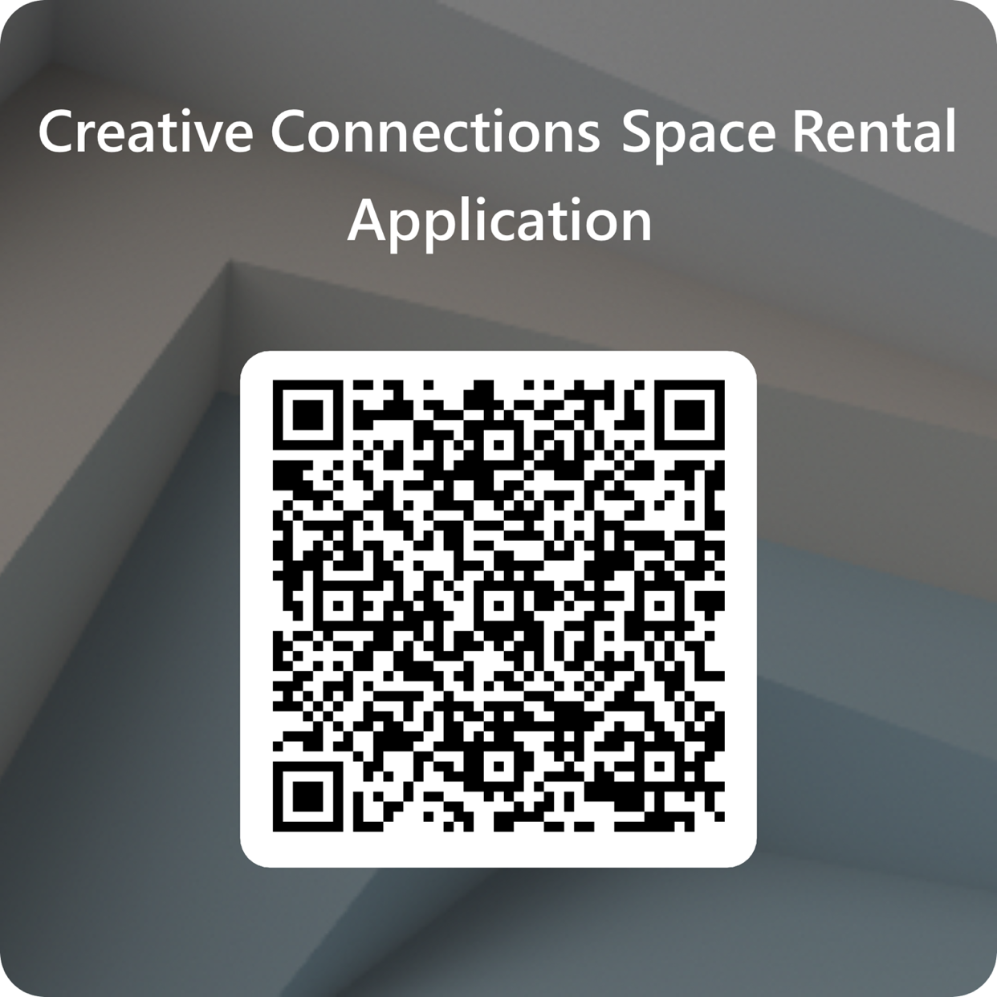
If you have read through and are happy with the information, please scan the QR code and complete the questionnaire. I will contact you for photos of your items. Thank you for your time and interest.

